Building Enterprise Financial Software in 2026

Part 1: AI changes the economics, not the discipline
For most of my career, large financial institutions have had two uncomfortable options when they needed serious enterprise software.
The first was to build it themselves. This was common in large banks, especially around core systems and critical post-trade infrastructure. It gave control, but it required large teams, long timelines, deep institutional memory, and a high tolerance for cost.
The second was to buy a vendor product and tailor it to the institution. That could mean hosted software, self-hosted software, or a heavily customised package. The trade-off was different, but not necessarily better. Pricing was often opaque. Timelines tended to move in proportion to complexity. Customisation created dependency. Replacement became so difficult that even problematic systems survived because the pain of moving away from them outweighed the visible benefit.
In practical terms, not much has changed in decades. We have had waves of new processes, tools, architectural fashions, delivery methods, and promises. Some helped. Few fundamentally changed the economics of building large enterprise financial systems.
The biggest improvements, in my view, came from hardware. Faster machines, cheaper compute, better networks, and more storage quietly changed what was possible. Now that same hardware foundation has made modern AI practical. The theory behind much of this is not new. I studied AI theory based on work from the 1960s during my undergraduate years in the late 1980s. What has changed is that the theory now has enough compute behind it to become useful at industrial scale.
That has been an epiphany for me.
The public conversation around AI is often fear, hype, or tabloid drama. My own experience has been more practical and more positive. AI has not removed the need for judgement. It has not removed the need for architecture, domain knowledge, testing, or taste. What it has done is compress the time between a good idea and a working implementation, provided the work is structured in a way that gives the model a high probability of success.
That qualification matters.
AI does not make weak engineering strong. It amplifies the environment you give it. If the architecture is vague, the language inconsistent, the tests brittle, and the domain poorly described, AI will produce more confusion faster. If the system is built from clear patterns, familiar technology, constrained terminology, and executable specifications, AI can become a serious force multiplier.
That became my shorthand for the whole approach: stacking the deck.
If the model is probabilistic, then the job of the engineer is to improve the odds. Choose the patterns, language, tests, boundaries, and guardrails that make the right answer more likely. That idea sits at the core of the project, and it is the reason AI compressed the work rather than turning it into a faster way to create slop.
This article is based on my experience building a large post-trade enterprise application from scratch, and what that experience suggests for the financial industry.

From enterprise habit to enterprise possibility
Most of my work has been around trading systems: front office, middle office, and back office. I have worked with vendor solutions, enhancements to existing processes, and in-house systems. I have always had a long-running ambition to understand the business deeply enough to build a technically strong product that customers would actually want, rather than merely tolerate.
The question I wanted to answer was simple:
Could one experienced analyst/developer, using modern AI tooling, build a large enterprise post-trade application?
By analyst/developer I mean the older version of the role: the person who can move between product ownership, business analysis, architecture, development, testing, and support. Not because one person is better than a team, but because AI changes the leverage of someone who can connect those disciplines.
The application I built was a real-time post-trade platform covering the kinds of capabilities that large financial institutions recognise immediately:
- trade capture, sorting, enrichment, and validation
- securities, cash transactions, postings, and positions
- lifecycle events across post-trade workflows
- entitlements, both manual and sourced from external systems
- charges, taxes, and fees
- access rights, tenancy, and data security
- reporting and operational views
- matching and settlement workflows
- exception management and four-eyes approval
- AI-assisted operational support, such as identifying breaks and likely causes
Technically, the goals were equally deliberate: clean code, one source of truth, domain-driven design, testable behaviour, observability, reproducible deployment, canonical identifiers, strong service boundaries, and enough discipline to stop AI making things up in the gaps.
The result became Illuminatio: a Java/Spring Boot microservices estate with gateway, config, registry, admin, security, messaging, GraphQL, Liquibase, observability, and domain services across areas such as trade, settlement, treasury, subledger, SWIFT, lifecycle, search, organisation, market data, and entitlements.
In plain terms, it has the shape of a serious banking or capital-markets backend platform, not a small application.

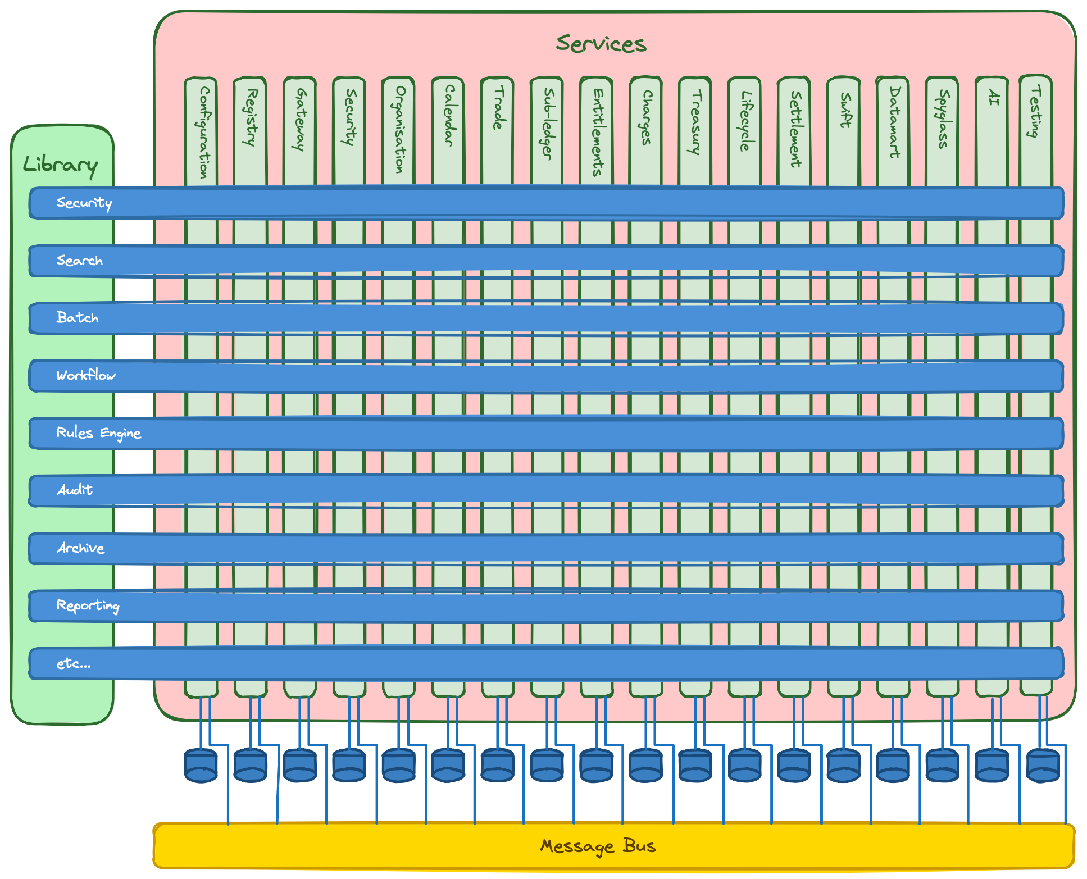

Did AI make enterprise software faster?
Yes, but not by magic.
The application reached deployment stage in Docker containers in roughly the equivalent of nine to twelve person-months of effort, compressed into a much shorter calendar period. Without AI, I would expect a comparable effort to require a team of perhaps seven to ten people over a couple of years.
That does not mean AI simply replaces the team. It means AI changes the economics of what a deeply experienced generalist can do.
The speed came from a combination of factors:
- choosing proven technologies
- creating repeatable patterns
- using BDD as executable specification
- reviewing aggressively
- refactoring when patterns repeated
- keeping domain language consistent
- asking AI for options before committing to infrastructure decisions
- slowing down when the problem was not yet well understood
The last point is important. AI can make it tempting to keep generating. That is dangerous. When the work involved infrastructure, architecture, or unclear domain concepts, the better move was to ask for options, compare trade-offs, and then decide.
When the knowns were known and the plan was clear, AI was extremely fast. When the problem was fuzzy, AI needed human judgement.
Fred Brooks wrote in “No Silver Bullet” that there is no single development breakthrough that removes the essential complexity of software. I still think that is true. AI does not remove the essential complexity of enterprise financial systems. But it can reduce a great deal of accidental complexity, especially around repetitive implementation, test scaffolding, documentation, refactoring, and pattern completion.

What this means for financial institutions and vendors
The implications for the financial industry are significant.
Buy versus build has always been a difficult decision. Vendor platforms offer speed, expertise, and packaged capability. Internal builds offer control, specificity, and ownership. Historically, the internal build option was constrained by time, team size, and risk.
AI changes that balance.
It becomes more plausible for smaller, sharper teams to build serious systems if they have:
- deep domain knowledge
- disciplined architecture
- strong test automation
- familiar technology
- clear terminology
- operational guardrails
- enough engineering judgement to know when not to trust the model
This creates pressure for SaaS and enterprise vendors. They still have advantages: product maturity, sales channels, regulatory credibility, support, integrations, and procurement familiarity. But their customers will increasingly ask why a system costs so much, takes so long to change, and still does not fit.
At the same time, institutions may decide to consume or acquire smaller AI-enabled product teams rather than buy large vendor platforms. The barrier to entry will not disappear, especially in regulated finance, but the economics are shifting.
The future may also revive an older job shape: the analyst/developer. In an AI-assisted world, a person who can understand the business, shape the architecture, write and review code, define tests, and operate the system has extraordinary leverage.
The old phrase is apt: “A jack of all trades is a master of none, but oftentimes better than a master of one.”


Conclusion
AI has made it faster to build enterprise financial software, but it has not made the hard parts disappear.
The lesson from this project is not “let AI build the system.” The lesson is: create the conditions in which AI can be useful.
For enterprise finance, that is not a small shift. It may change who can build, what can be built, how quickly institutions can respond, and how much tolerance remains for systems that survive only because replacing them used to be too hard.
Part 2 looks at the practical side: how to stack the deck in your favour with boring technology, strong boundaries, guardrails, codebase discipline, and behaviour-driven development.

